Design Challenge Briefs
Facilitator copy — two scenarios for in-interview use
These briefs are for use by the interviewer. The candidate receives only the one-sentence prompt at the start of the session. All additional context is held back and disclosed only if the candidate asks specific questions — that's the point.
Time: 15–30 minutes depending on role level. Use the shorter end for co-ops and intermediate roles; allow more time for senior and above.
Scenario A — Highway Rest Stop
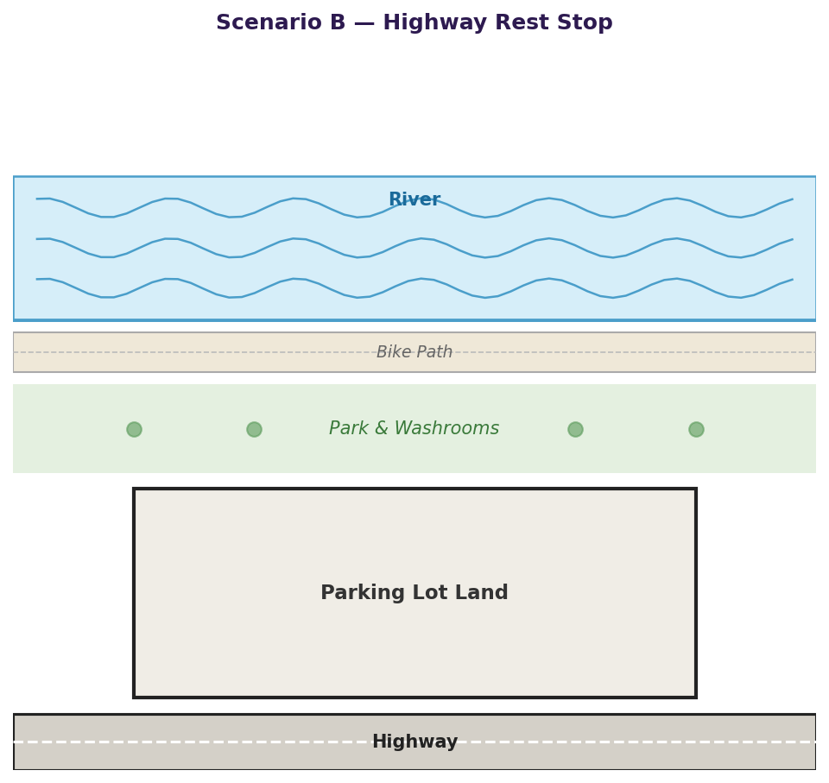
Site reference — share this view if candidate asks for a diagram
PROMPT TO READ ALOUD TO CANDIDATE
“We are a company that has a piece of land. We brought you in to help us with conceptual designs. Please design a parking lot that will meet our needs.”
Time: 15–30 minutes | Tool: Miro, Mural, or whiteboard
Scenario A — Context to disclose only if asked
Only answer questions the candidate asks. Do not volunteer the following unprompted:
The site
- Rectangular lot, approximately 20×8 car lengths — long and skinny
- Highway on one long side, river on the other long side
- Park with picnic tables and washrooms on one end (not in scope for improvement)
- The exact dimensions aren't critical — what matters is understanding the constraints
The context
- The highway runs between a port and a city — heavy mixed traffic
- Traffic includes commercial trucks/buses (5×1), RVs (2×1), and family cars (1×1), plus possible motorcycles and cyclists
- Two accidents have already been reported from motorists pulling off the highway to use the existing park and washroom — that's why a proper lot is needed
Bonus areas (strong candidates will surface these unprompted)
- Accessibility: ramps, accessible parking near the washroom entrance
- Security: lighting, emergency phone, CCTV
- Signage: highway-facing signage with enough advance notice for trucks
- Surface: heavy pavement requirements for trucks; motorcycle-appropriate surface
Scenario A — Evaluation signals
Strong response
- Asks about site shape and dimensions before drawing anything
- Asks who uses the lot — identifies the vehicle type mix independently
- Asks about the highway context and traffic volume
- Accounts for large vehicle turning radii, separate entry/exit
- Mentions accessibility, lighting, or safety unprompted or when lightly prompted
- Communicates reasoning as they sketch, rather than silently drawing

Weak response
- Starts drawing immediately without asking a single question
- Designs a generic shopping-mall lot with rows of identical spaces
- Does not account for vehicle size variation
- Silent throughout — no communication of reasoning
Scenario B — Carnival Grounds
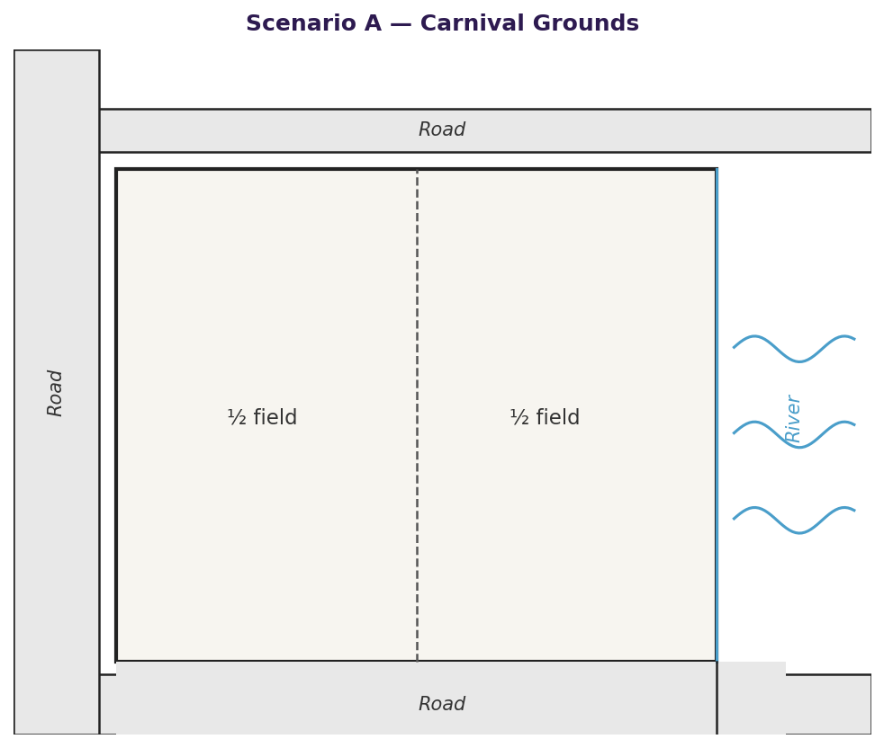
Site reference — share this view if candidate asks for a diagram
PROMPT TO READ ALOUD TO CANDIDATE
“Please design a parking lot for us.”
Time: 15–30 minutes | Tool: Miro, Mural, or whiteboard
Scenario B — Context to disclose only if asked
Only answer questions the candidate asks. Do not volunteer the following unprompted:
The site
- Rectangular converted farmer's field
- Half the field is the parking lot; the other half hosts a carnival
- Three sides of the field border roads; one short side borders a river
The context
- Rural location outside a small town — a carnival draw means long queues of arriving vehicles
- Traffic includes RVs and family cars (1×1); motorcycles and bikes possible
Bonus areas (strong candidates will surface these unprompted)
- Accessibility: parking close to the carnival entrance
- Security: site lighting
- Queueing: how to manage traffic backup onto the surrounding roads
- Surface: gravel or paved, drainage considerations for a converted field
- Washrooms, garbage collection within the lot
Scenario B — Evaluation signals
Strong response
- Asks 'what kind of lot?' or 'what's the context?' before starting
- Identifies the carnival / event use case through questions
- Considers crowd flow from lot to carnival entrance
- Accounts for RV sizing and spacing
- Thinks about ingress/egress given the road and river constraints

Weak response
- Begins drawing immediately with no questions
- Draws a standard uniform-space lot without context
- Ignores the site shape and boundary constraints entirely
- No mention of the relationship between the lot and the carnival
Shared facilitation notes
Time guidance
- 15 minutes: co-op and intermediate — shorter is intentional. When candidates struggle, a longer session helps no one.
- 20–30 minutes: senior and above — allow more time for depth, alternatives, and unprompted bonus areas.

If the candidate is stuck
- Hint: 'Have you thought about who will be using this space?'
- Hint: 'Are there any constraints on the site you'd want to understand?'
- Do not offer the context unprompted — even if they are struggling. The hint should point them toward asking, not give them the answer.

Remote delivery
- Use Miro or Mural with a shared board. The candidate should share their screen.
- How they navigate and use remote tools is itself a signal for distributed teams.
- Keep your camera on and note-take visibly — this is a collaborative session, not a passive observation.
Facilitator notes field:

